Family Entry
Important Reminders
- Your fair probably has dates when entry is accepted into the fair. Be sure to complete your entry (including the final “Submit” step) prior to the cut-off date.
- Recommended browsers: Google Chrome or Mozilla Firefox. Older versions of Internet Explorer may cause unexpected results.
- Register all entries for each exhibitor in the family before proceeding to the Payment section.
- Be sure to click the “Submit” button when you have completed your entries. Entries are not final until they have been submitted.
- Check your email inbox for a confirmation email with a list of your entries and any related fees.
- You will receive a second email when your entries have been approved by your fair.

Steps  - Go to http://www.fairentry.com and click “Find Your Fair”. | 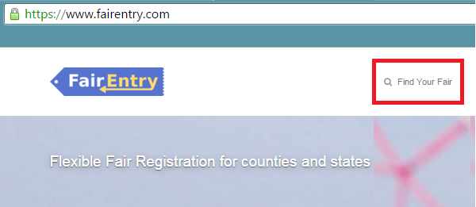
- Filter by your state, click Search, and then click on the correct fair. | 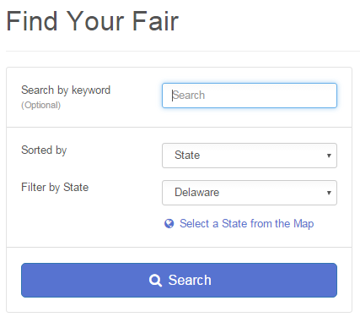
- If you are a Talbot 4-H member, log in with your 4honline account. They system already knows your name, address, etc.  If you are an Open exhibitor, click the link to create a FairEntry Account. Fill in the requested information (name, address, etc.) to create your account.  You will now be able to sign in to FairEntry using your e-mail address and password. | 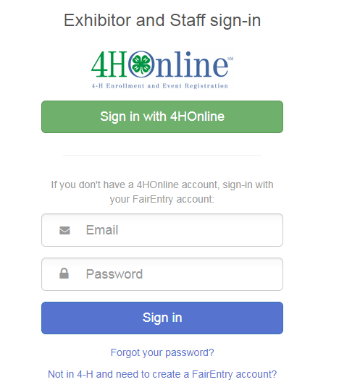
- Click “Begin Registration” | 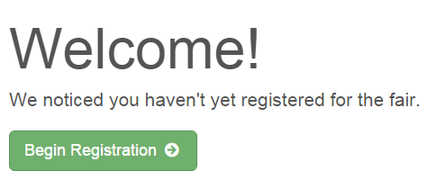
Exhibitor Information  The Talbot County Fair is configured for individual entries. | 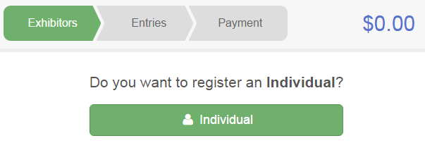
5. 4-H families select a member from the list and begin registering exhibits.  Open exhibitors click “Register an Exhibitor” and add family members.  Open exhibitors will be asked to enter contact information before creating their first entry. Home phone number and address are required.  All exhibitors will be asked a few fair questions such as T-shirt size before creating their first entry. Click “Continue to Entries.” | 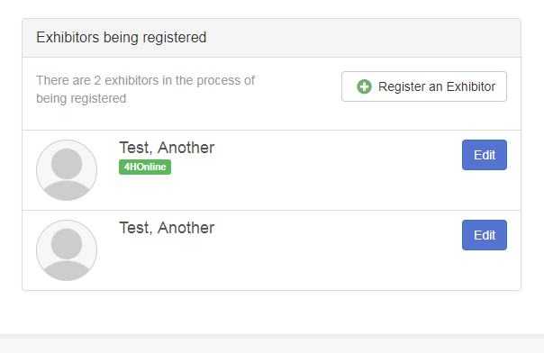

Creating Entries
Each exhibitor can have multiple entries. One entry must be made for each item, animal, class, etc. For example, if an exhibitor is bringing 2 photographs, two entries into the photography class must be created. If an exhibitor is showing one horse in 5 events, five class entries must be created. Once all entries have been created for the first exhibitor, you have the choice of creating another exhibitor in this family (and entries) or proceeding to check-out (submitting the entries, whether or not fees are charged). IMPORTANT! DON’T GO TO THE PAYMENT SECTION AND CLICK THE FINAL “SUBMIT” LINK UNTIL AFTER YOU HAVE REGISTERED THE ENTRIES FOR ALL EXHIBITORS IN YOUR FAMILY! WHEN YOU CLICK SUBMIT, YOUR ENTRIES ARE LOCKED.
- Select an exhibitor in your family.  - Click Add an Entry beside the correct exhibitor (if more than one has been created). | 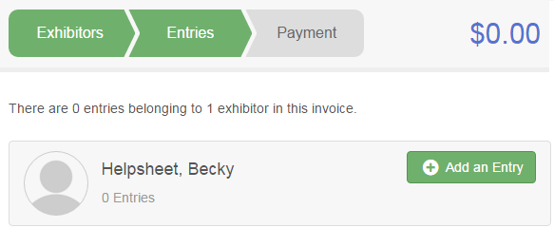
- Click Select beside the first department you wish to enter. Any departments that are not available for entry will be noted as “Not Available” with a short explanation.  - After you select a department, you will see a list of divisions to select from, and then a list of available classes. Also notice that there are blue “Change” links in case you mistakenly select an incorrect department, division, or class.  - After you have selected the class, click the green Continue button. | 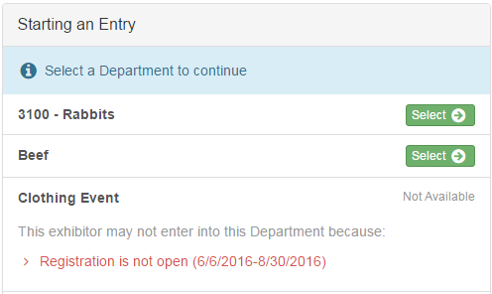
- If this is an animal class entry, you may be asked to specify which animal will be exhibited in this class. You will see the option to “Add an animal”.
- Fill in all of the fields with information about the animal you intend to exhibit. Click Create and Add Animal when finished.
- If the animal information was entered incorrectly, you have the option to either Remove From Entry (creating a new animal) or Edit Animal Details. When it’s correct, click Continue.
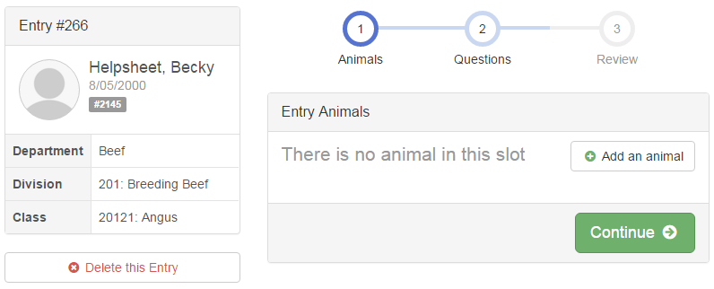
- The Review screen allows you to double check this entry for accuracy, and make any changes necessary. When the information is correct, click Continue and that class entry is complete.
- When each class entry is complete, you have 3 choices for what to do next:  - If all class entries have been completed for one exhibitor, you can Register another Exhibitor in this family.  - If this exhibitor has more class entries to make, you can Add another Entry for this Exhibitor.  - If all entries for all exhibitors in the family have been completed, Continue to Payment to finalize and submit your entries. | 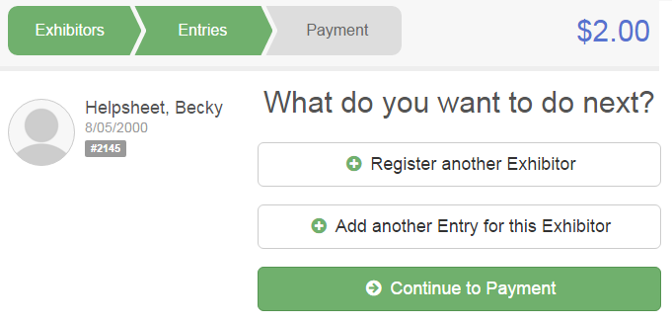
- Review your entries for completeness and accuracy. Notice the Summary and Detail buttons at the top of the list on the right. If there are errors, click on the green Entries section at the top of the page. Click Continue when all information is correct.  IMPORTANT: DON’T GO TO THE PAYMENT SECTION AND CLICK THE FINAL “SUBMIT” LINK UNTIL AFTER YOU HAVE REGISTERED THE ENTRIES FOR ALL EXHIBITORS IN YOUR FAMILY! WHEN YOU CLICK SUBMIT, YOUR ENTRIES ARE LOCKED. | 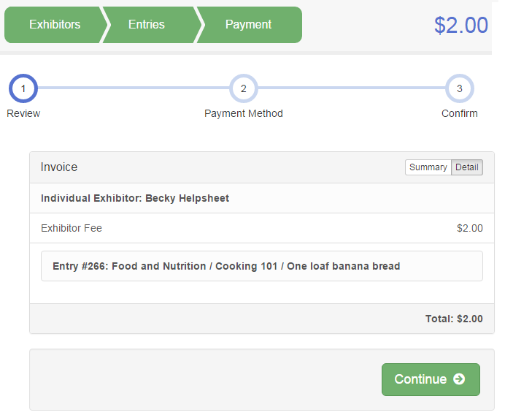

- Read the payment instructions and select your method of payment. Some fairs allow credit card payments, and others do not. NOTE: Even if you owe no money (no fees are charged) you must click Continue to the last “Confirm” step to submit your entries.

- Read the information in the “After you Submit” section. You may also have to check a box to “Agree to Terms”. Click Submit to finalize the entries for the exhibitors in this family. After you click Submit, no changes are possible to these entries.

DON’T CLICK “SUBMIT” UNTIL YOU HAVE REGISTERED THE EXIBITS FOR EVERYONE IN YOUR FAMILY! If you hit submit too soon, you won’t be able to make any changes unless you ask the fair manager to send your invoice back to you.

You will receive a confirmation e-mail message that you can print for your records. You may also log back in to the website at a later date and print a list of your entries.

