For Immediate Release
Date: 01/28/2026

Trailblazers 4-H Club News

Reporter, Maci Pritt

The Trailblazers 4-H Club kicked off the 2026 year with its first meeting on Tuesday, January 20. The meeting began with a warm welcome to new members and guests, followed by the recitation of the pledges, and members receiving their meeting agenda outline. Clover members were then dismissed to participate in a fun activity led by 4-H volunteers, while youth members and families remained to conduct club business.
Minutes from last meeting were read and approved. Newly elected officers took their positions for the first time at this meeting and consist of President Rae Smith-Pritt, Vice President Dani Hughes, Secretary Olivia Hayhurst, Treasurer Molly Hayhurst, Reporter Maci Pritt, and Activity Leaders Reece Tasker, Lindsay Miller, Sammy German, and Aleeah Pratt.
Members were reminded of several upcoming events, including the Garrett County Public Speaking Contest on January 23, the 4-H Arctic Friends Class hosted by the Garrett County Extension Office on January 26, and the deadline for record books, livestock contracts, and 4-H Online enrollment on January 31.
Families were also reminded of the inclement weather policy, which may affect scheduled 4-H meetings or activities.
The remainder of the meeting focused on planning club meetings and activities for the upcoming year. Members and families were encouraged to share ideas and suggestions for future events.
The Trailblazers 4-H Club’s February 2026 meeting date is to be determined and will include a regular 4-H meeting followed by a roller-skating activity.

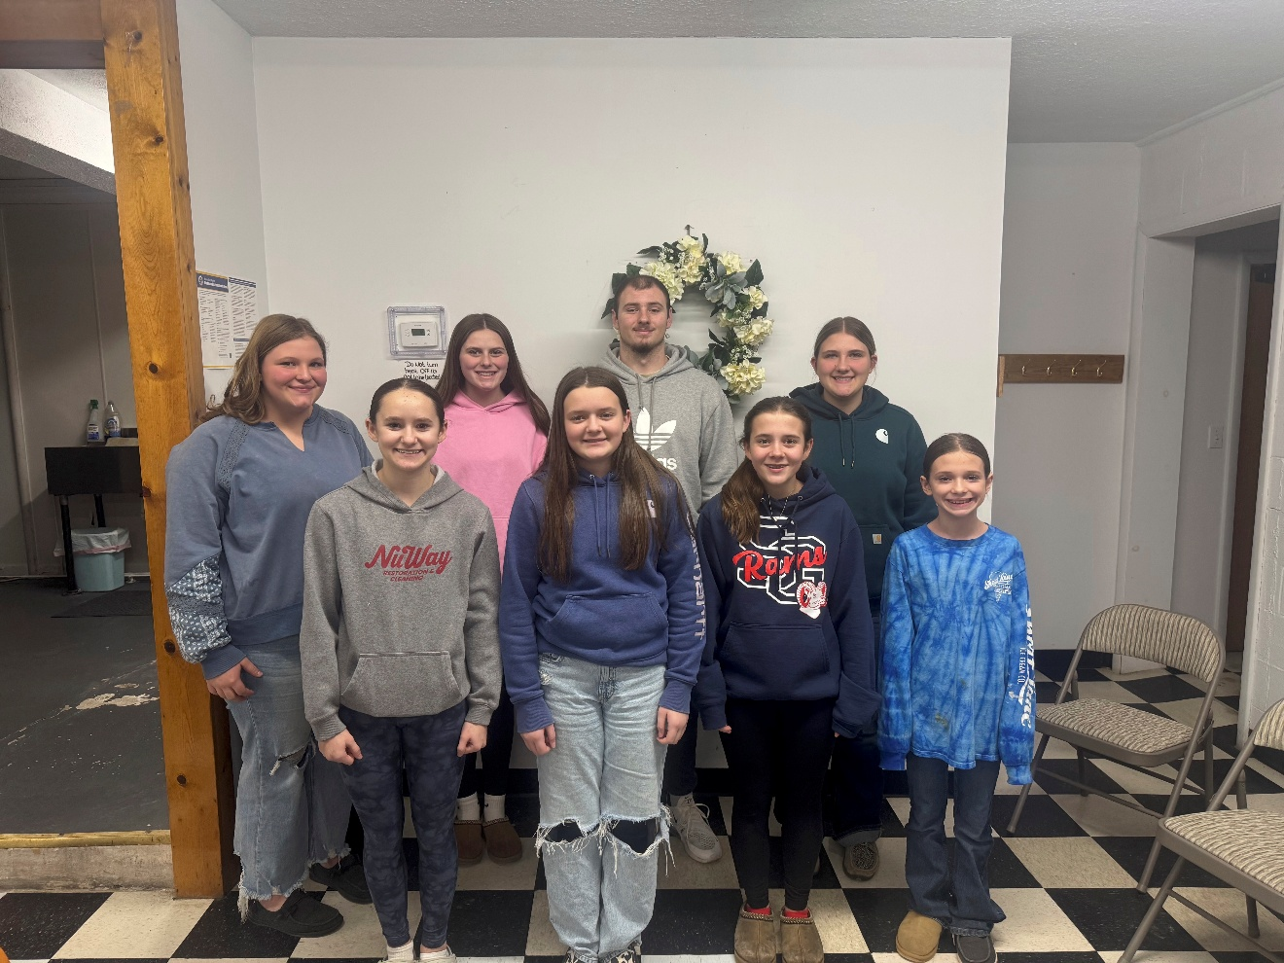

Pictured Above are the 2026 Trailblazers Club Officers. Back Row (left to right) Molly Hayhurst, Lindsay Miller, Reece Tasker, Olivia Hayhurst. Front Row (left to right) Aleeah Pratt, Dani Hughes, Sammy German, and Maci Pritt. Missing from the picture is Rae Smith-Pritt.

