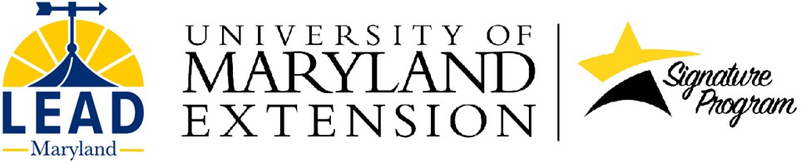

LEAD Maryland Fellowship Program Reference Form

Instruction for the Fellowship applicant: The applicant must ask three (3) people to provide references. The references should be submitted directly to the LEAD Maryland Foundation, not the applicant.

Be sure to approach people with your request well in advance of the October 1 deadline. Give this form to a person you believe can comment on the nature and scope of your character, leadership, and service potential, and your readiness to successfully complete a two-year fellowship.
Choose people such as trusted co-workers, clients, and community members. References are not to be completed by relatives and close personal friends.
Please share this form as needed, so that each person asked to supply a reference has this form available.
Instructions for the person completing the form: Thank you for assisting the LEAD Maryland Fellowship Program by providing a reference for the Fellowship applicant. The reference provides general support or description of the applicant’s nature and scope of character, leadership and service potential, and their readiness to successfully complete a two-year fellowship.

The LEAD Maryland Foundation provides educational leadership development Fellowships. The Fellowship is intended for people who have demonstrated emerging leadership abilities and leadership potential in agriculture, food, natural resources, and/or rural communities. Applicants who may have already become strong leaders or have obtained a high level of development of personal and leadership skills, or have become proficient in their service to others, may not rank as high as those who show greater potential for growth through program participation. Fellows must have an ability and willingness to teach and share, at the same time they must have the maturity and readiness to learn, grow, and change to become leaders who serve others.

References are due October 1, 2025. Return completed reference forms directly to the LEAD Maryland Foundation by email, mail, or delivery:

Email: leadmd@umd.edu

Mail or Deliver: LEAD Maryland Foundation, 124 Wye Narrows Drive, Queenstown, MD 21658

Do not share the filled-out reference form with the applicant. Send it directly to the LEAD Maryland Foundation.

LEAD Maryland Fellowship Program Reference Form
Please type or print clearly. This reference will be held in strict confidence and should be returned directly to the LEAD Maryland Foundation at leadmd@umd.edu .

Reference for: (Name of person applying for a LEAD Fellowship)

Rank how you know the applicant, with 1 being “superficially” to 10 being “know very well.”

Superficially 1 2 3 4 5 6 7 8 9 10 Very Well

Circle a ranking number or provide a number here:

State how you know the applicant, and how long you have known the applicant:

Please indicate your reasons for believing that the applicant—as well as the agricultural, natural resources, or rural communities—would or would not benefit through this individual’s participation in the leadership development training program. Your frank, confidential comments are most appreciated.

2

LEAD seeks participants who demonstrate ability, willingness, and a need to learn, share, teach, lead, and work as a team. Using a few words, or short phrases (for example: He/she is working on this skill; excellent, acceptable, fair; He/she has room for growth; I have not observed this ability, etc.), please share your thoughts about the applicant after each line below.

- Applicant’s sense of self-awareness to draw on strengths and overcome weaknesses:

- Applicant’s confidence to move outside of their comfort zone and take on new challenges:

- Applicant’s maturity and readiness to learn, grow, and change:

- Demonstrated leadership skills, and skills to be a productive group member:

- Applicant’s understanding of current public issues and their ability to have constructive conversations with others about public issues, regardless of viewpoint:

- Applicant’s commitment to engage with others in their community and advocate for agriculture, natural resources and/or rural communities:

- Overall assessment of the applicant’s ability to become a leader by serving others, chairing committees, facilitating discussions, strategic thinking, building teams, solving problems, creating professional networks, building consensus, and influencing or shaping public policy:

Thank you for completing this reference form!
For the person providing the reference: (print or type):
Name

Title of Affiliation:

Phone: ________________________________________________________________________

Email: _______________________________________________________________________________

Signature:

